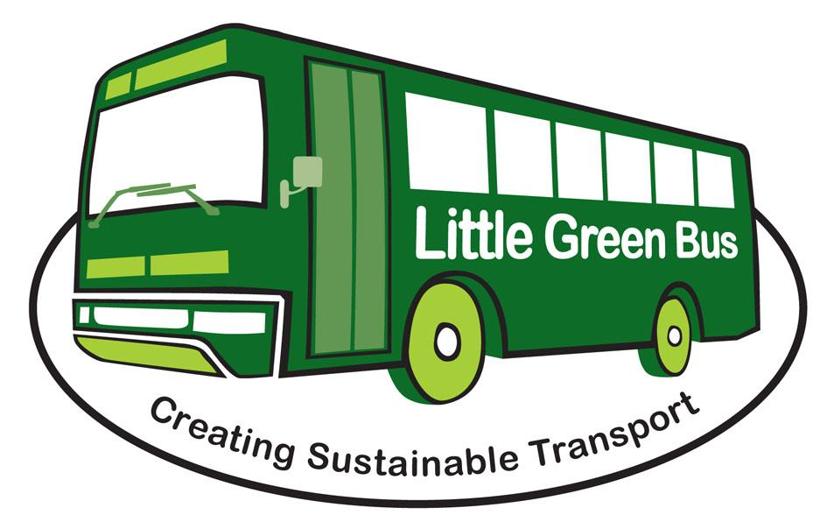


Little Green Bus Ltd
Unit 3 Upbrooks Industrial Estate
Clitheroe
Lancashire
BB7 1PL

Tel: 01200 444484

Dear Passenger

The following trips will run from Wednesday 2nd Oct 2024 to Wed 26th March 2025 inclusive. Where possible, two or three buses will be allocated per trip. All trips cost £12 per person and do not include the cost of any meals. All trips leave all destinations at 2.15 p.m.

Destination | WEDNESDAY
Heskin Hall Shopping Village, Chorley | 2 Oct
St Annes | 9 Oct
Brunch at the Barn at Scorton followed by Country run | 16 Oct
Bury | 23 Oct
Jak Hanson &/or Golden Days | 30 Oct
Oswaldtwistle Mills | 6 Nov
Barton Grange | 13 Nov
Heskin Hall Shopping Village, Chorley | 20 Nov
Birkacre Garden Centre Chorley | 27 Nov
Boundary Mill | 4 Dec
Dobbies | 11 Dec
Pendle Village | 18 Dec
Country Run with lunch at the Country Harvest Ingleton NEW | 8 Jan 25
The Courtyard Tarleton | 15 Jan
Dunelm/TK Maxx/Waitrose – Capitol Centre Preston | 22 Jan
Boundary Mill | 29 Jan
Bury | 5 Feb
Brunch at the Barn at Scorton followed by Country run | 12 Feb
Deepdale shopping | 19 Feb
Oswaldtwistle Mills | 26 Feb
Cleveleys | 5 Mar
Skipton | 12 Mar
Lytham | 19 Mar
Riggs | 26 Mar

HOW TO REQUEST THIS SERVICE

Seats will be allocated on a first come first served basis. Passenger can request as many trips as they want and can book on behalf of a friend if they are in agreement.

Please telephone the office on 01200 444484 to book your trips as soon as you can, as the trips get booked up quickly, it is easier to book early and it isn’t a problem if you later have to cancel the trips. You can post your trip selection or give it to a driver if you prefer.

You may pay on the day or in advance, any advance payments will be moved to future trips if notice of cancellation is given. All no shows will be charged in full.

We struggle to give exact times for pickups so this year we’re going to trial giving an half hour slot for you to be ready, as we have no control over road works or how long it can take a passenger to get onto the bus or the many other reasons that can make the bus early or late.

